Lecții on-line educație tehnologică și aplicații practice

1.Carmen Pavel is inviting you to a scheduled Zoom meeting.
Topic: Protectia consumatorului
Time: Apr 29, 2020 12:00 PM Bucharest
Join Zoom Meeting
https://us04web.zoom.us/j/74181463911
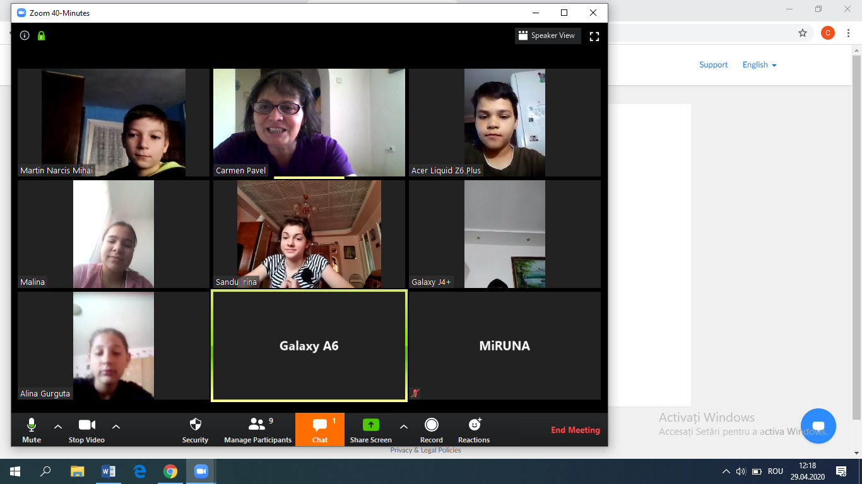

2.Carmen Pavel is inviting you to a scheduled Zoom meeting.
Topic: Ed.tehnologică VI A- Locuința
Time: Apr 28, 2020 02:00 PM Bucharest
Join Zoom Meeting
https://us04web.zoom.us/j/72664456431
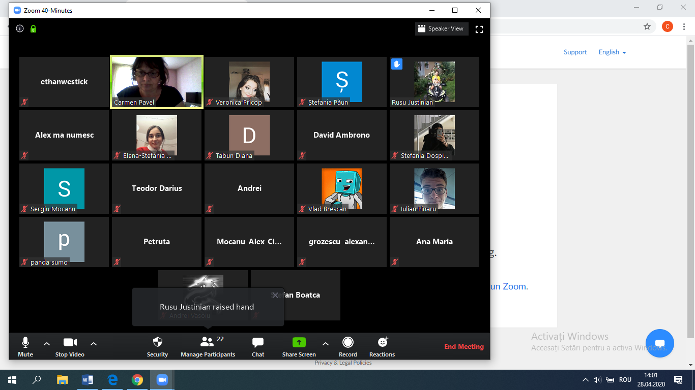

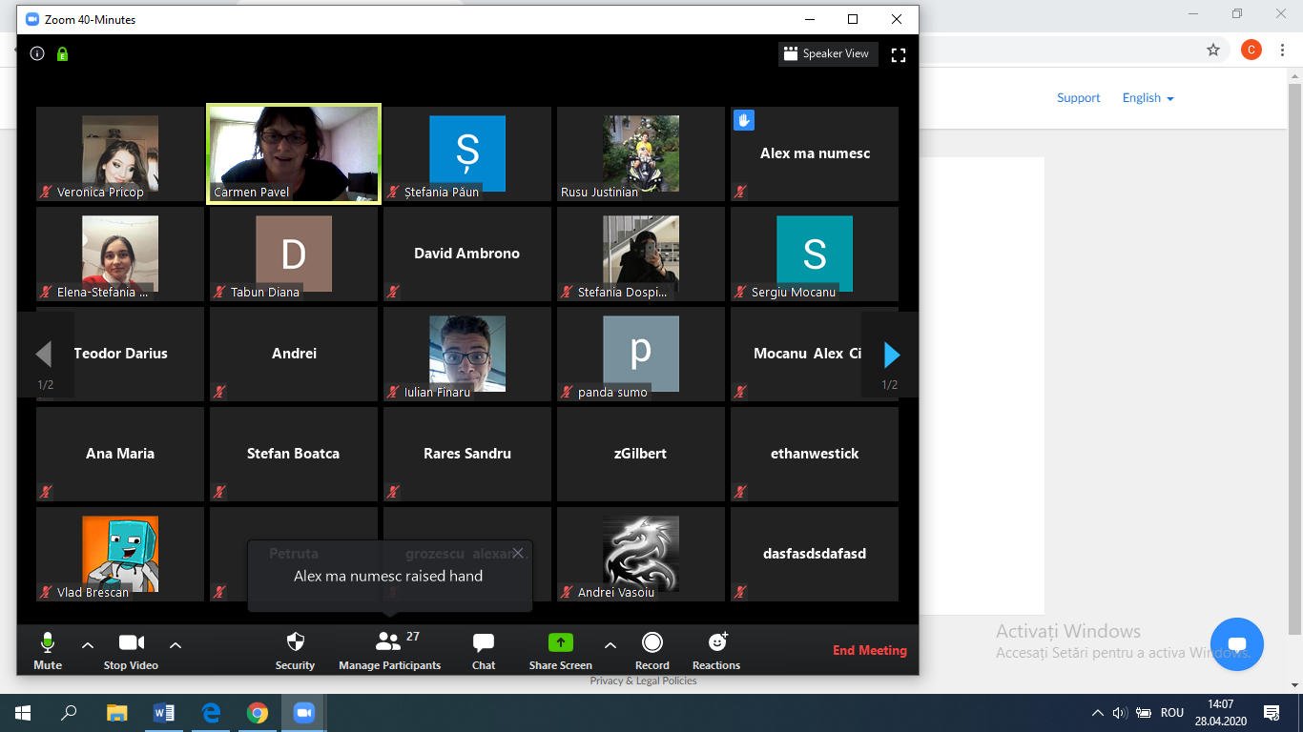

3.Carmen Pavel is inviting you to a scheduled Zoom meeting.
Topic: ed.tehnologică-Cauciucul
Time: Apr 28, 2020 12:00 PM Bucharest
Join Zoom Meeting
https://us04web.zoom.us/j/73244576676
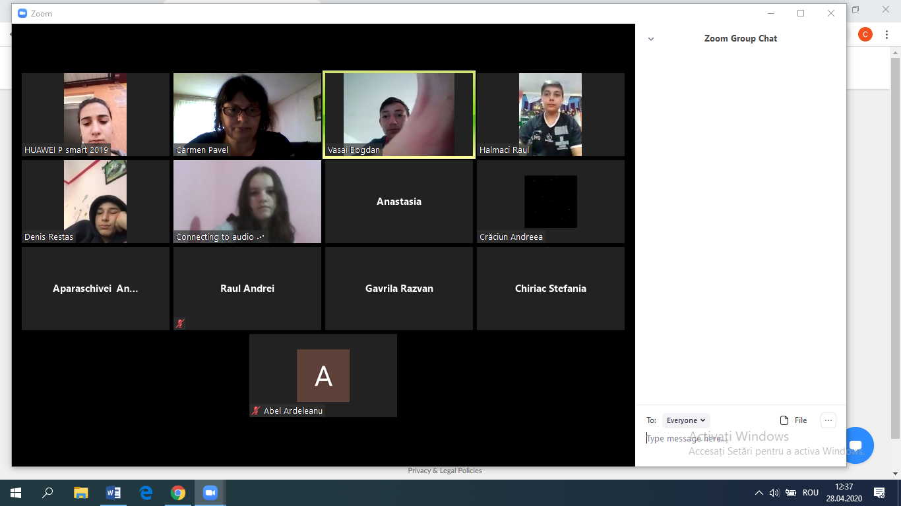
4.Carmen Pavel is inviting you to a scheduled Zoom meeting.
Topic: Educație tehnologică clasa a VIII-a B-Piața Muncii
Time: Apr 29, 2020 02:00 PM Bucharest
Join Zoom Meeting
